/* Ashok IPBC Morgage_Project R1SP3 Story4 Lab.docx 7.27.18*/

Homework:

4. Complete R1:SP3: Story 4 – Do Error handling on the data. For any problems, notify the loan officer via email so they can fix the errors. Explain the entire process with explanations, screenshots.

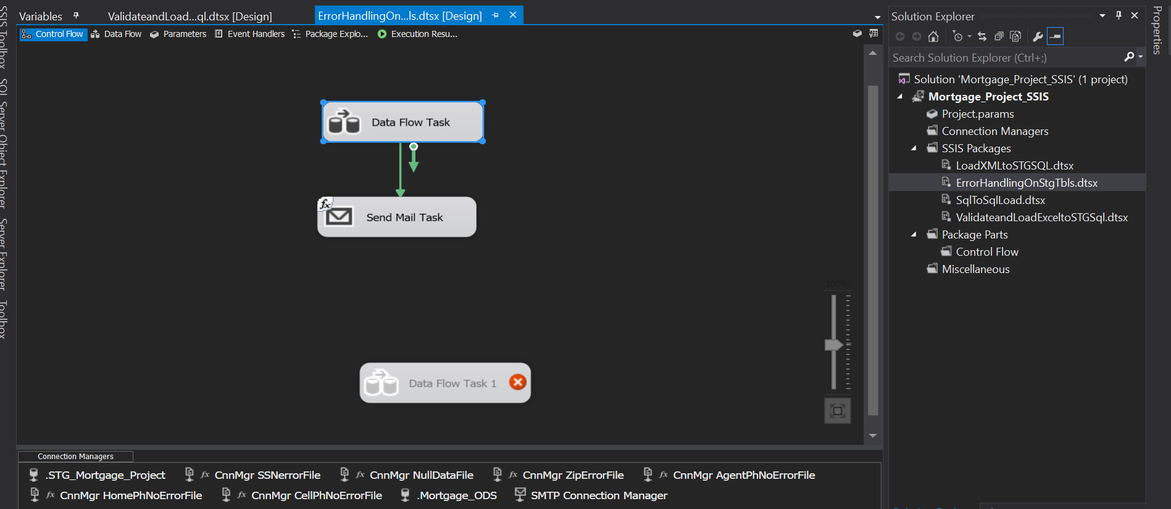

Now we are going to use data flow task and send mail task tool handle errors in our staging database table.

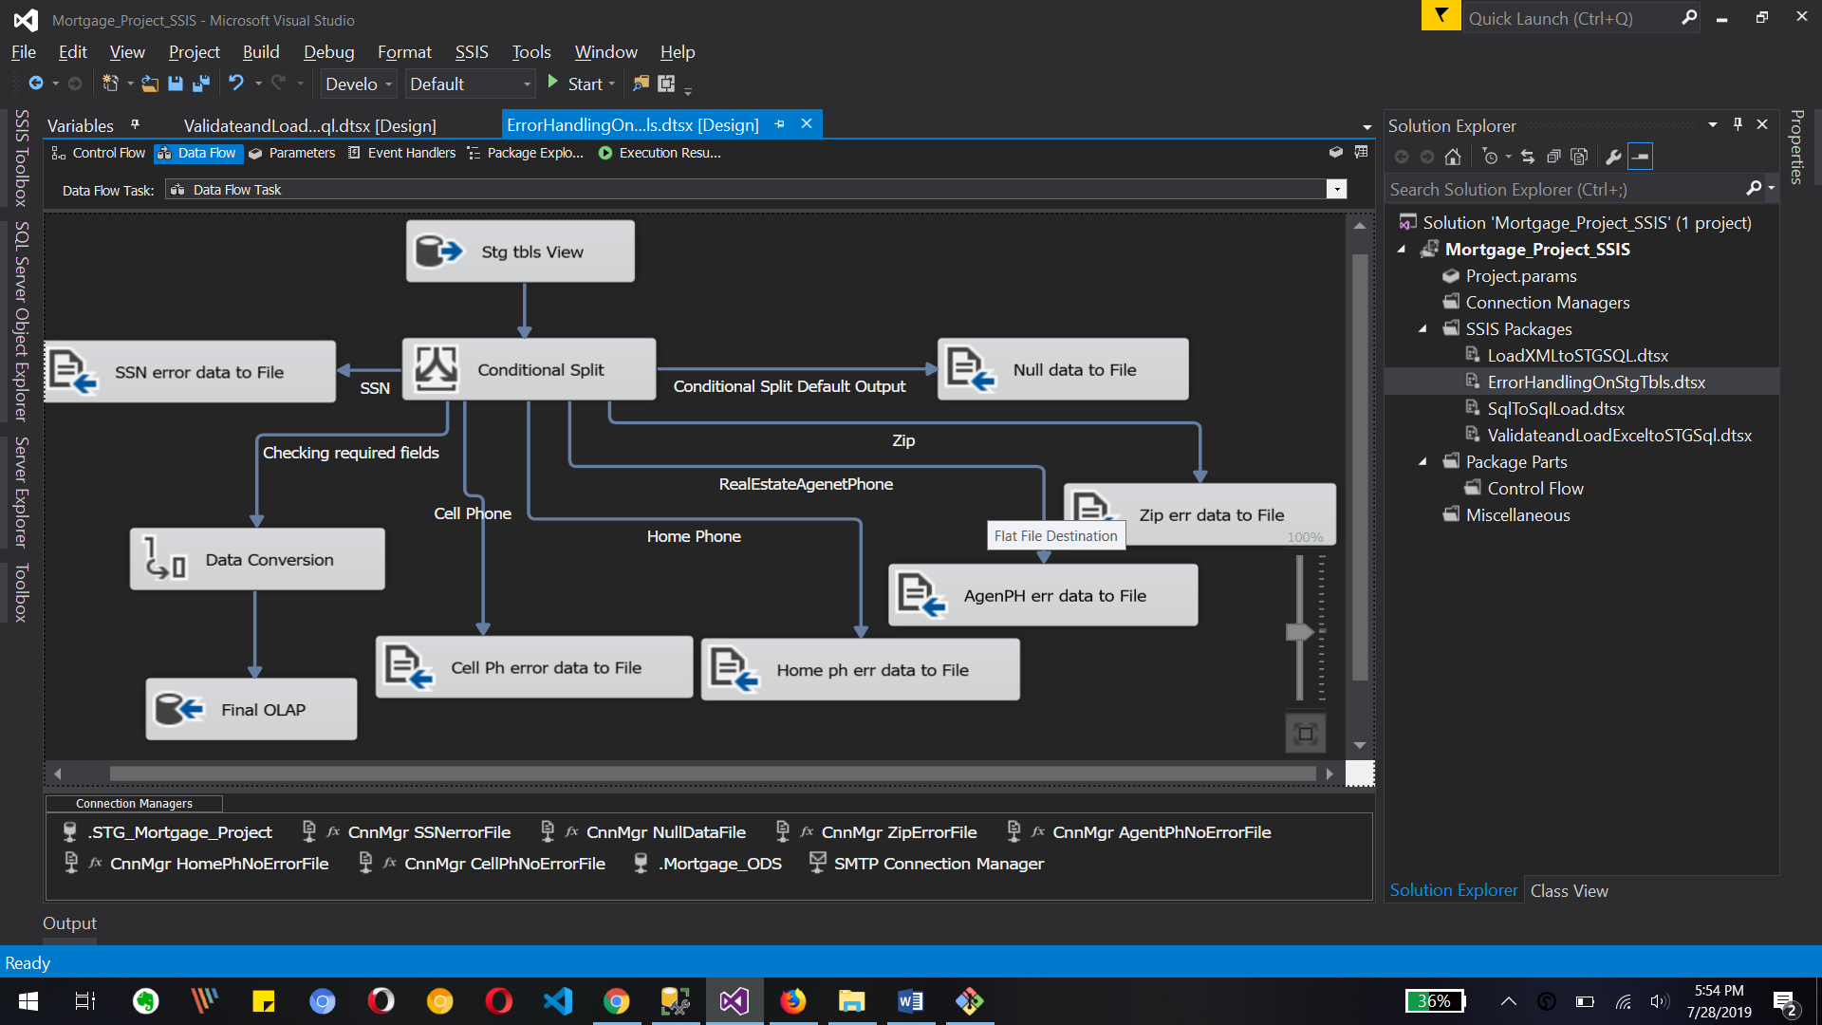

This is our data flow task where we use oledb source and conditionals split transformation where we create different output based on input data.

Also we are going to create flat file with error data so we can send those files back to loan officer.

Here we are going to use a data conversion for our olap database table.

And finally Viva copy all data from oledb Source database table tool olap database table end OSD.

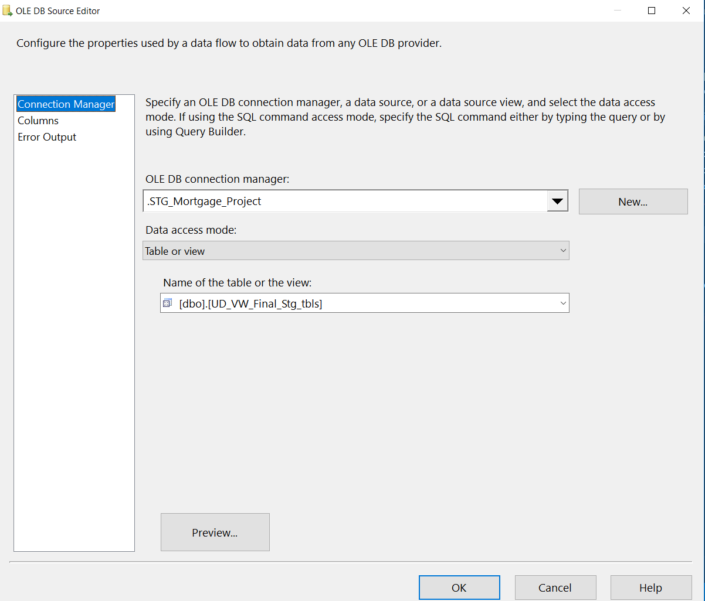

Above image is for oldedb database table selection where we use View from stg_tbls to access all data.

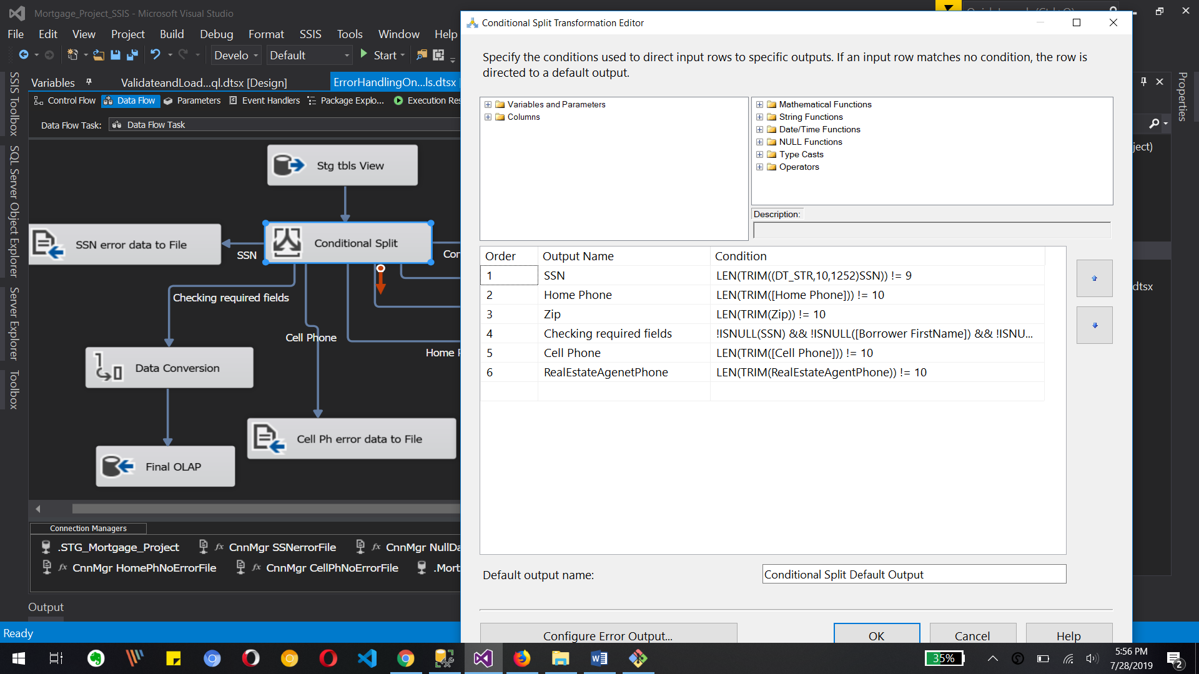

We use different condition to handle errors in data as a example SSN check, home phone number check, zip code check, null in data checking with “isnull” function, cell phone number or contact numbers length checking with Len function.

So here we will have total 7 outputs from this conditional split transformation and we will send those outputs to different source.

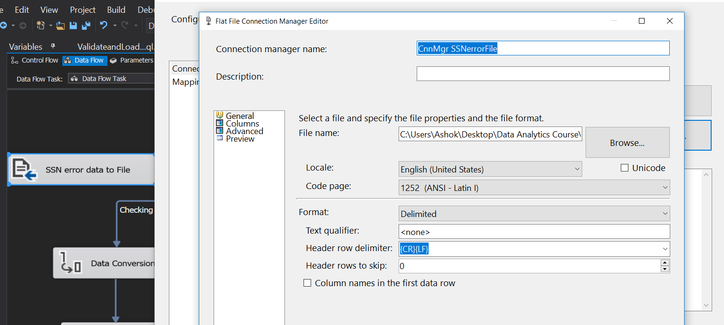

We need to configure flat file destination flat file location image, Also we do this same for other flat file destination.

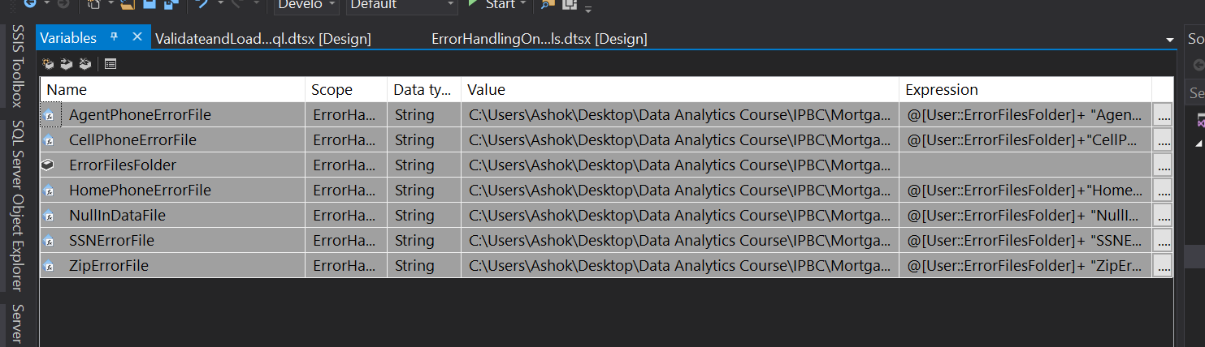

We use different variable to store flat file name and it's containing folder.

we will use those variables to store our flat files location in system so if we have to migrate our project from one server to another server we just change variable data or variable information.

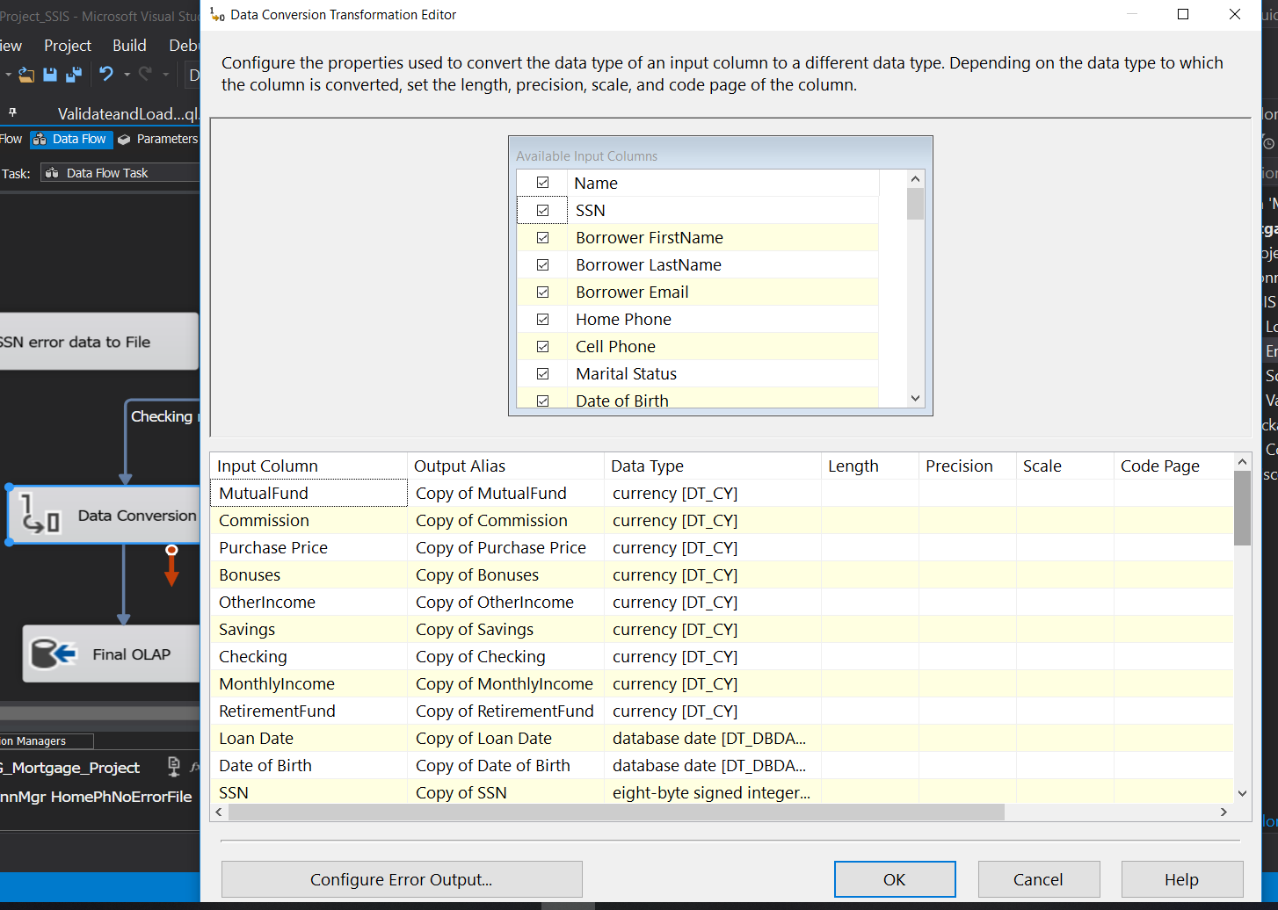

We use data conversion transformation where do we need to convert our data from oledb data types to Olap data types.

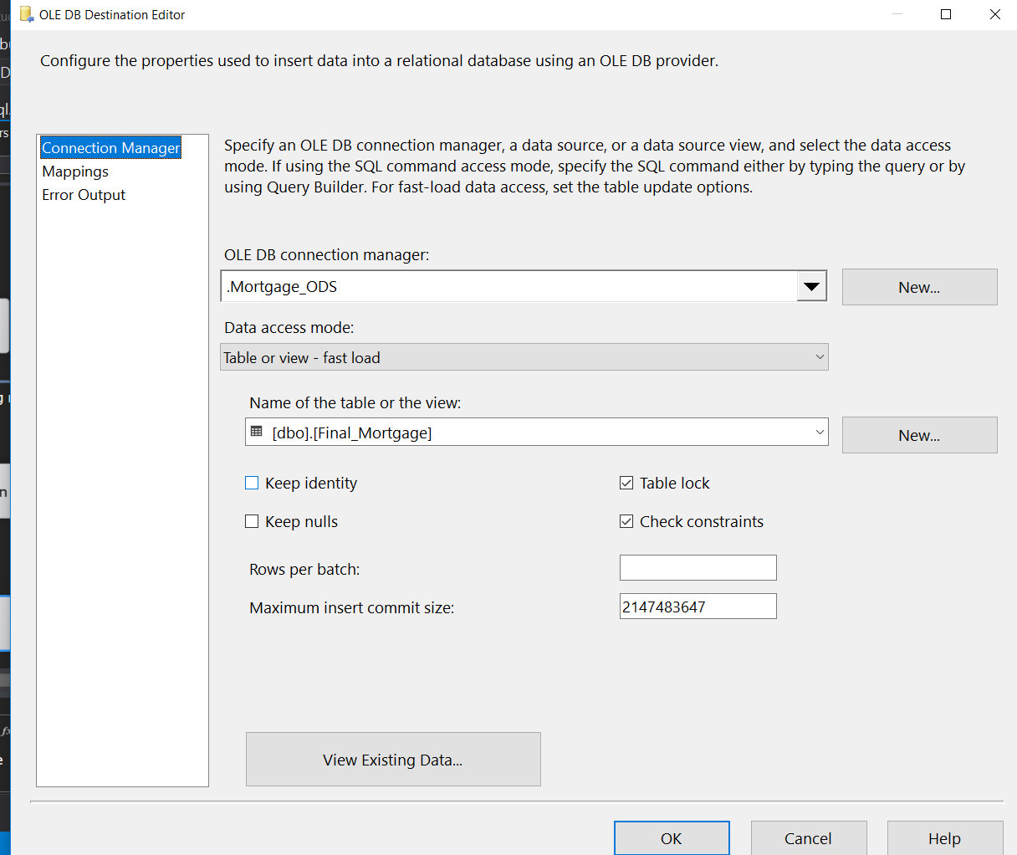

 Above image shows the database connection to mortgage ODS and its final mortgage table

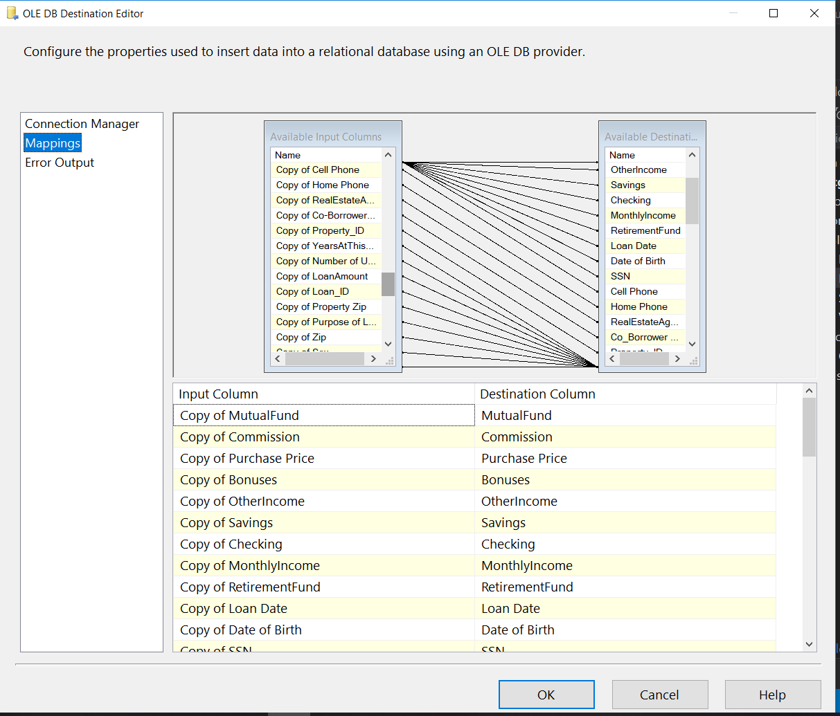Here we need to map our input columns and destination columns as shown in image

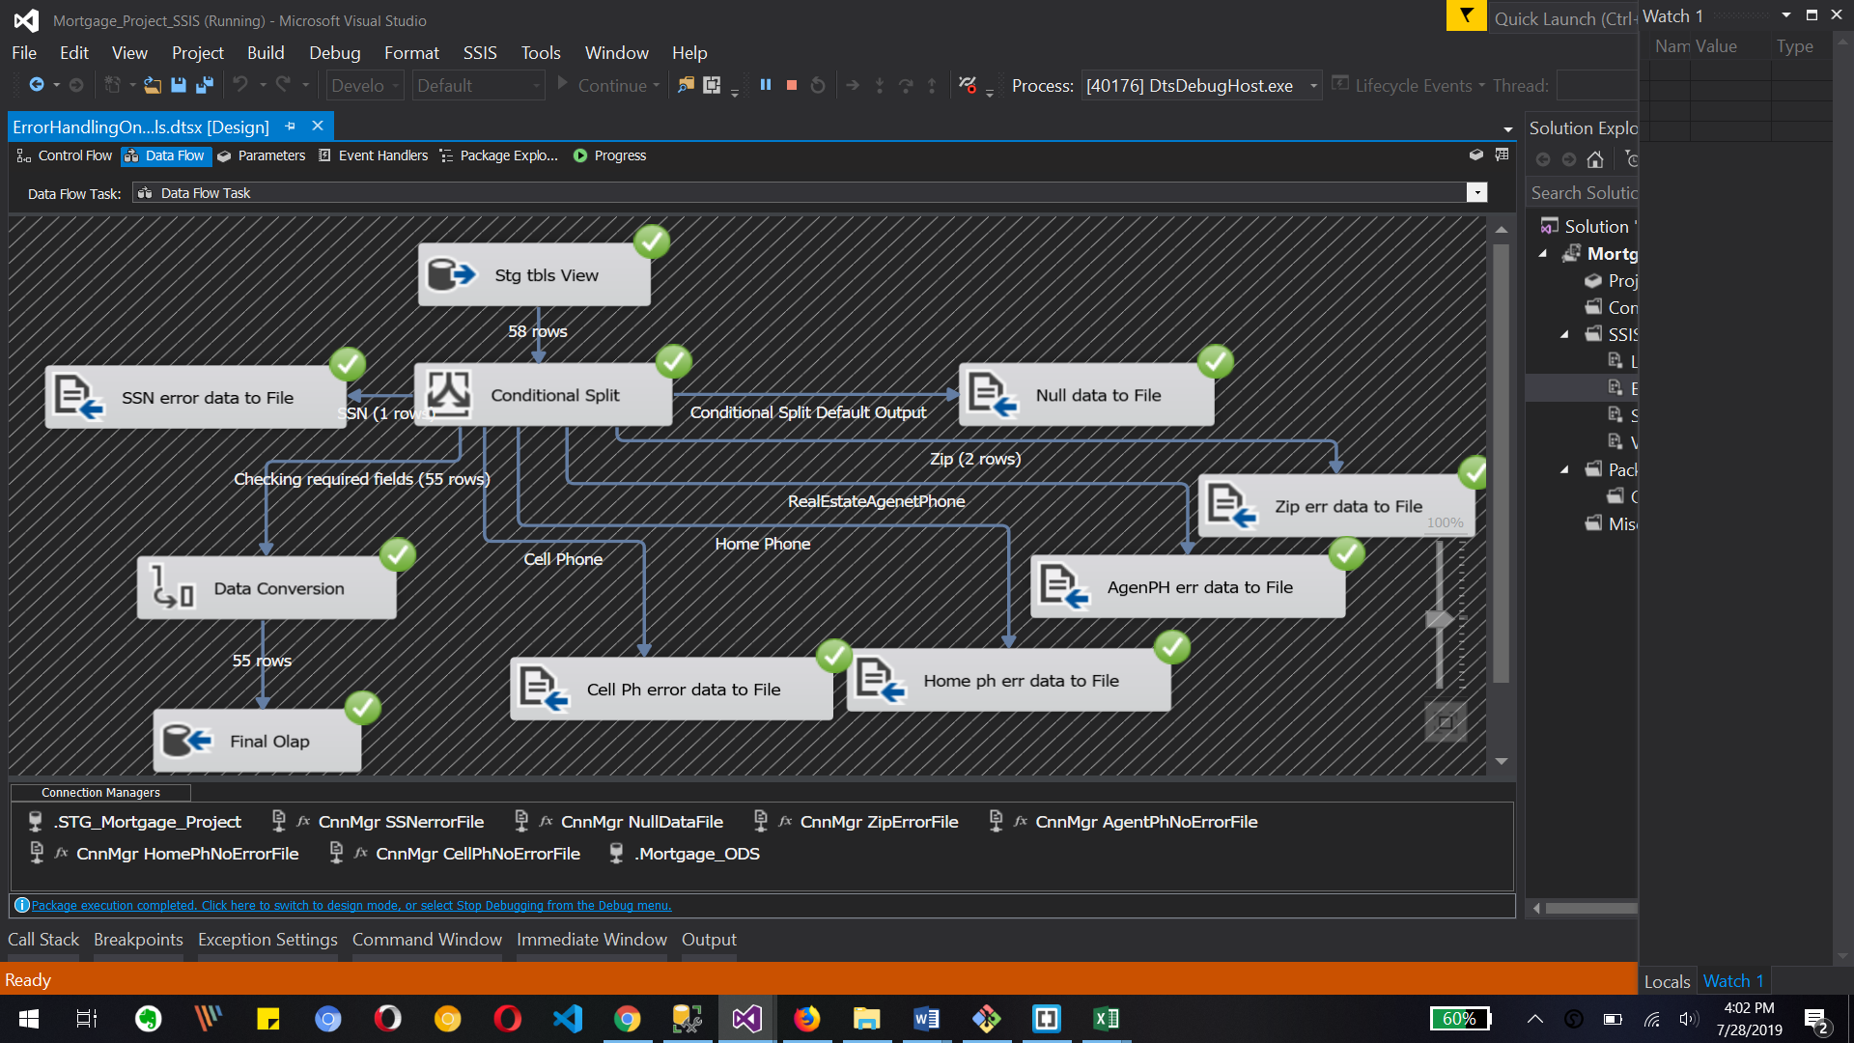

Once we run the dataflow task we can see there are two record with zip error file which has an error and one record for SSN data error file and we have total 55 records which are copied to our olap database table from oledb table with handling errors.

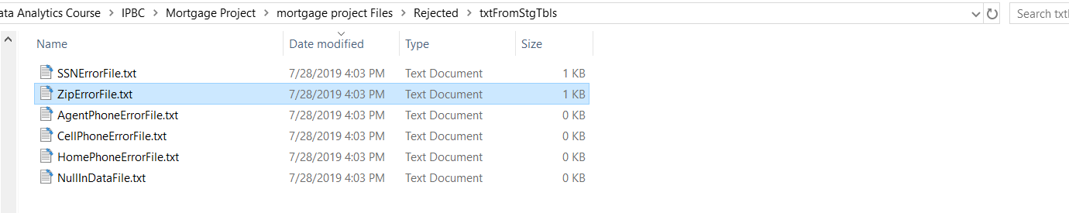

Here we can see one zip error file and 1 SSN error file which is as a text file created by our ssis package which contains records. One has SSN error and another has zip code errors

so that way we generate text files and we will use send mail task from ssis to send email to loan officer with this files as attachments.

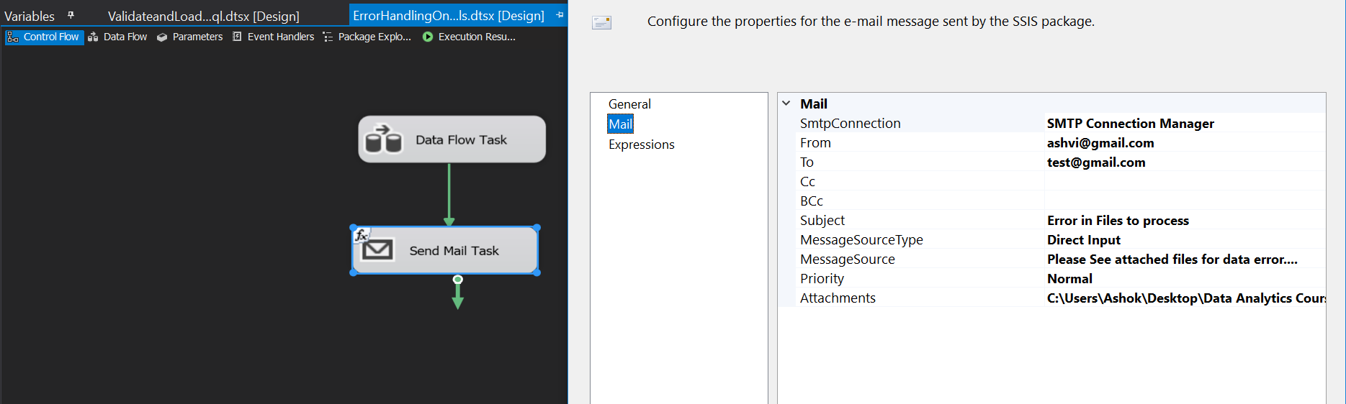

Once we complete the configuration of data flow task we will configure send mail task to send email to loan officer with error files as shown in image. So finally we could do error handling in stg table data .

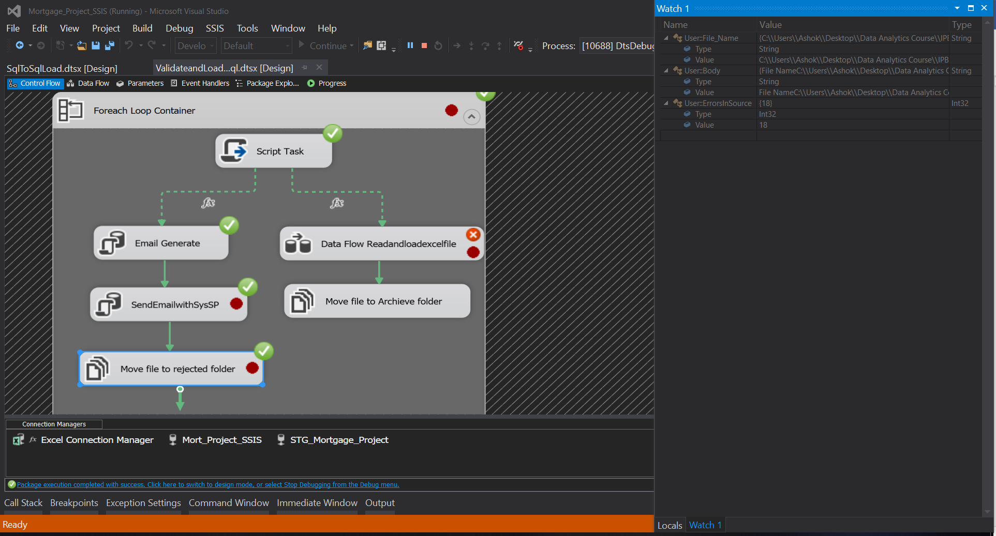

Above image is for data validation and columns validation for excel source files. Where we use script task to check columns validation for excel file data.

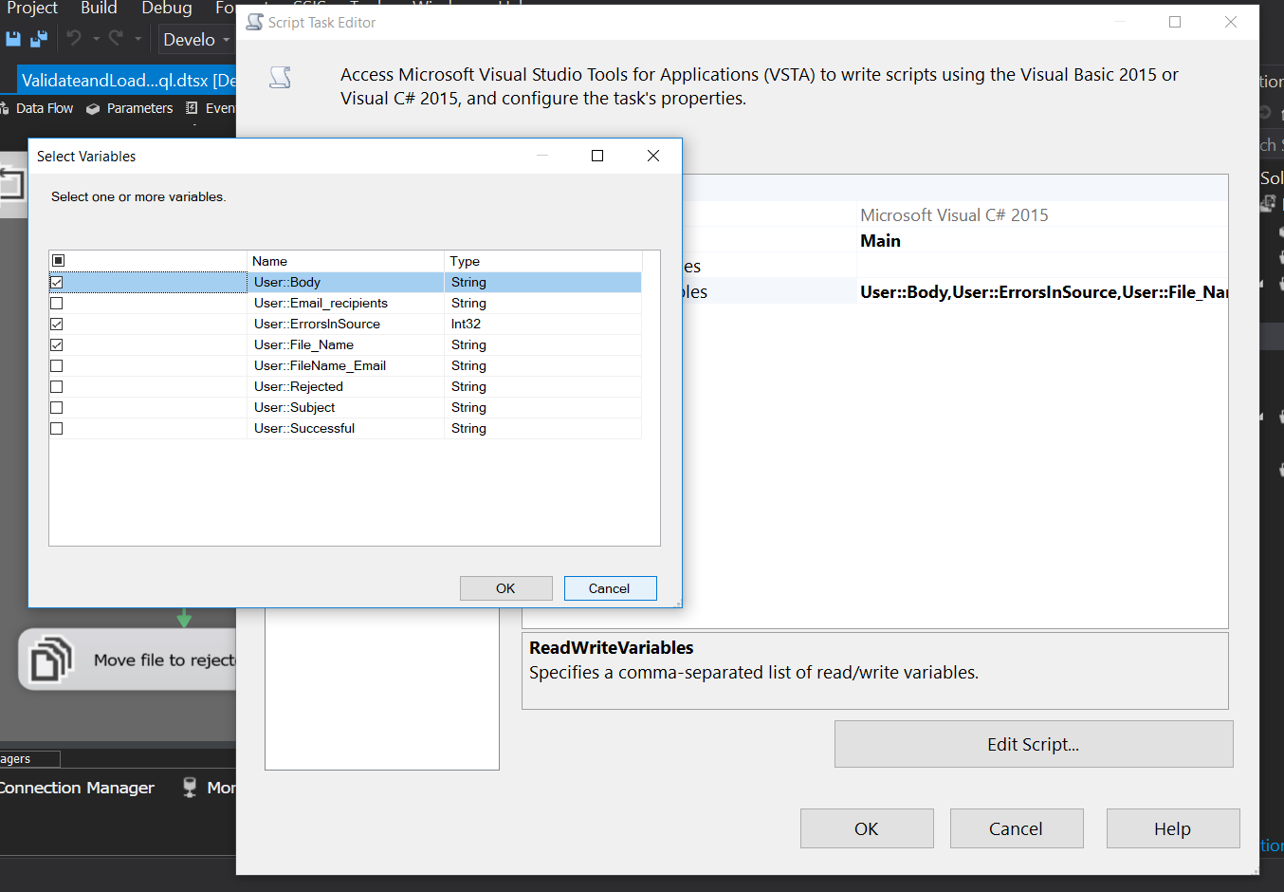

Above image is for Script task editor where we use different variables for data access in script.

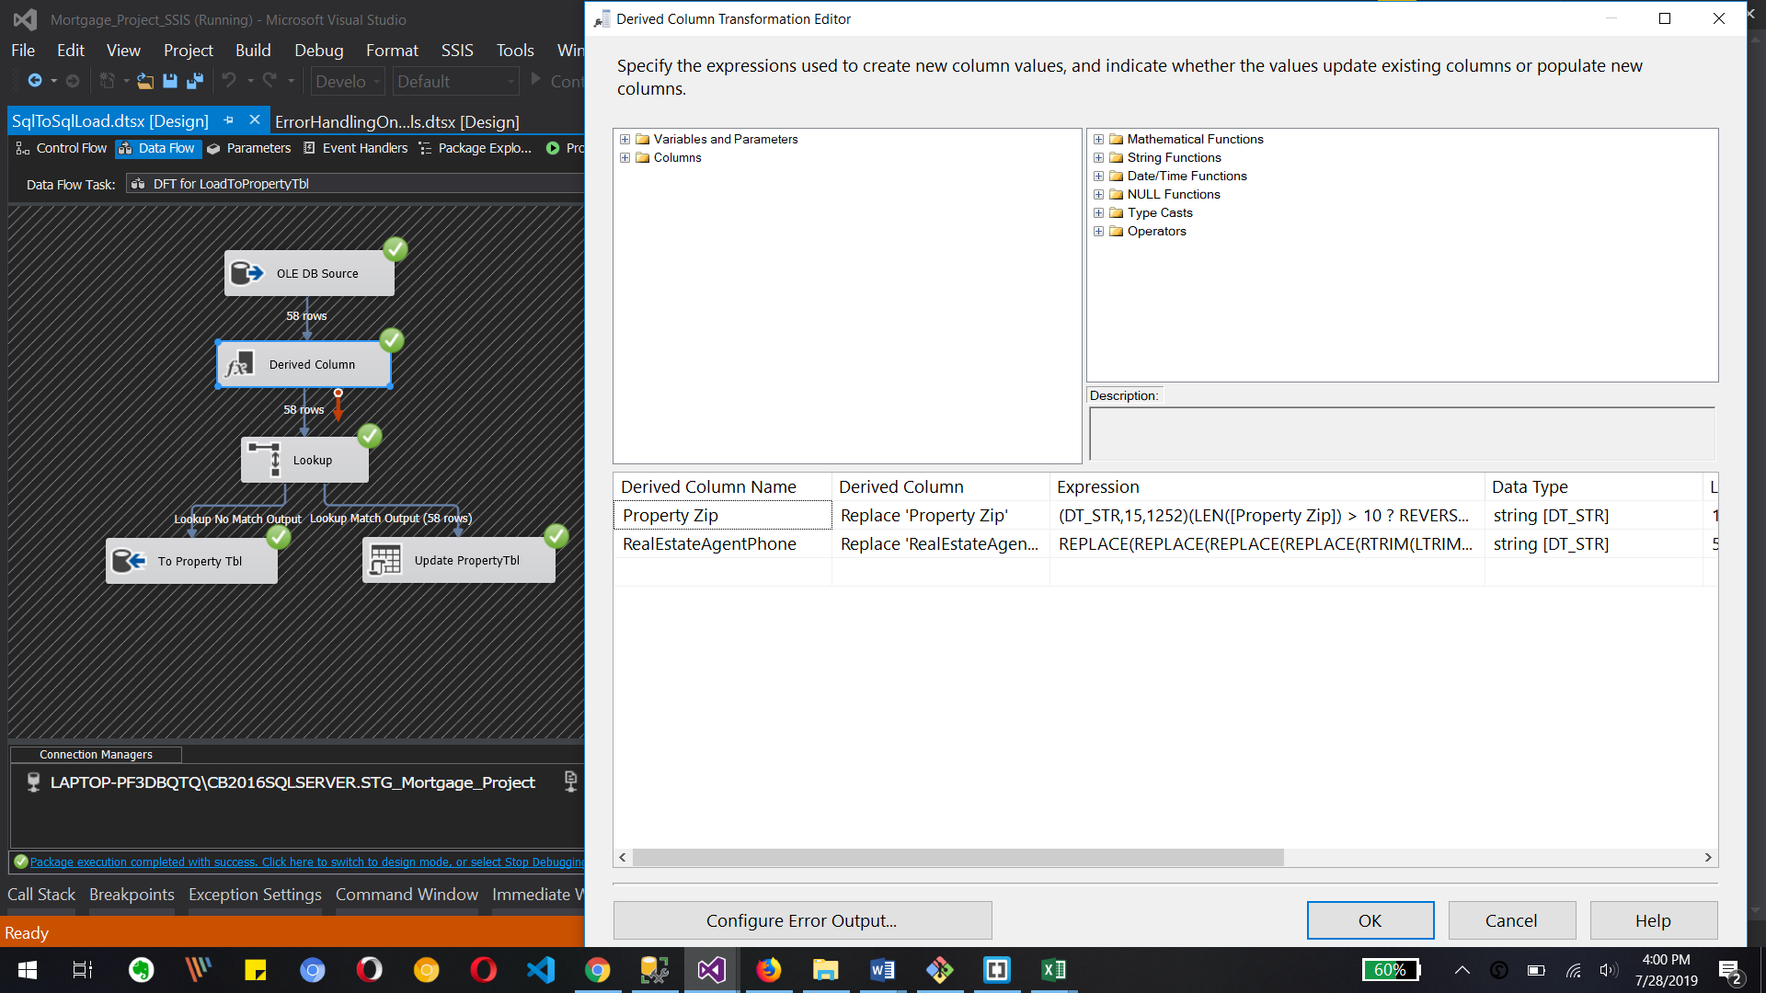

Above image shows the connection of Oledb source to Property table with derived column, lookup and oldebd command transformation. In derived column transformation we replace the zip code and Agen phone number for specific validation

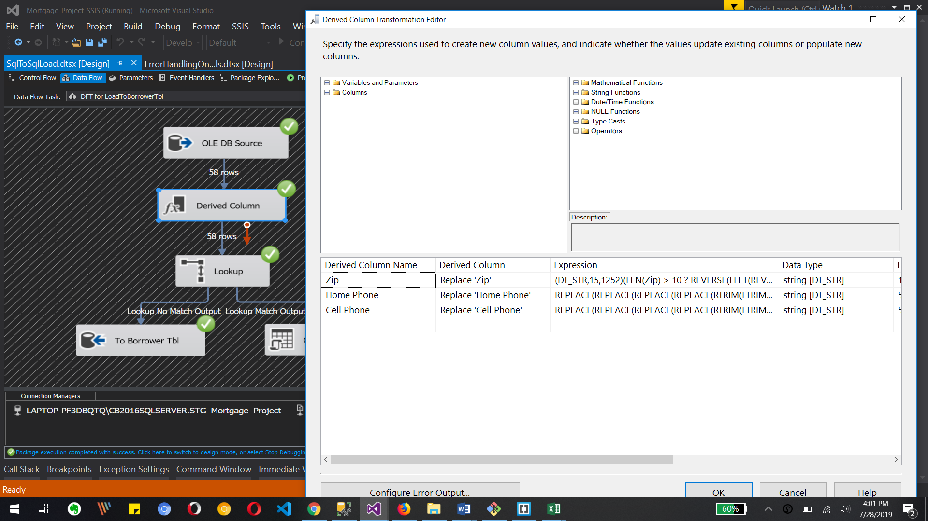

Same way we created zip, home phone and cell phone data with derived column where we use some functions to clear the data for our validations

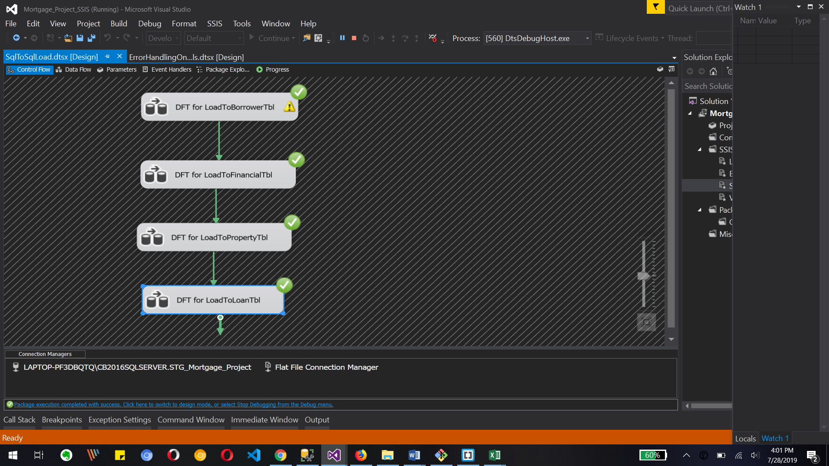

Above image is the Data flow task of which is inside for each loop container and it run successfully.



Above image trolls execute SQL task for generating email end execute SQL task for sending email with the help off stored procedure EXEC msdb.dbo.sp_send_dbmail .

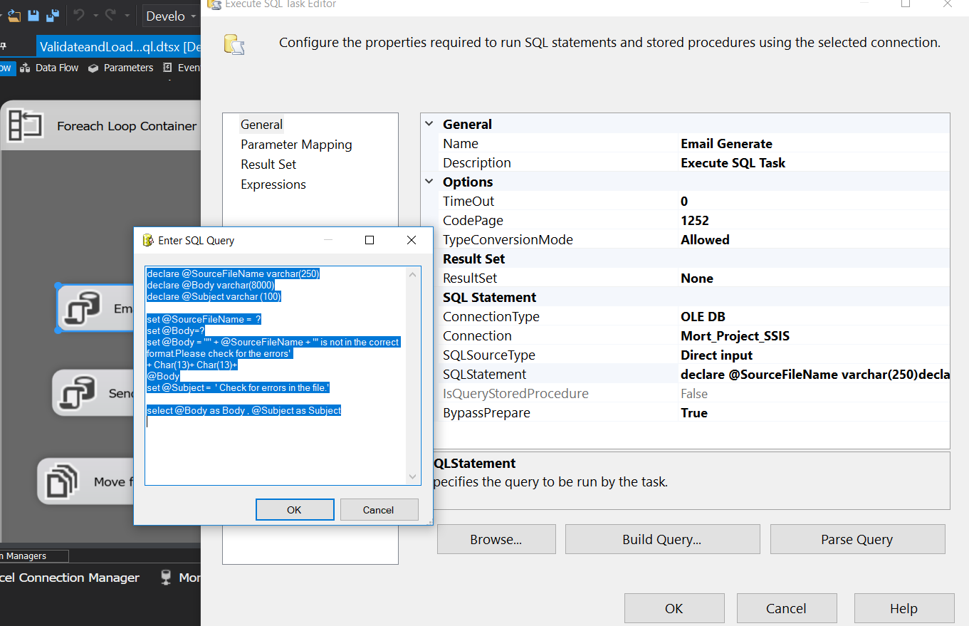

In this image we are going to run SQL query poor creating email bear we going to put recipients body and subject of email

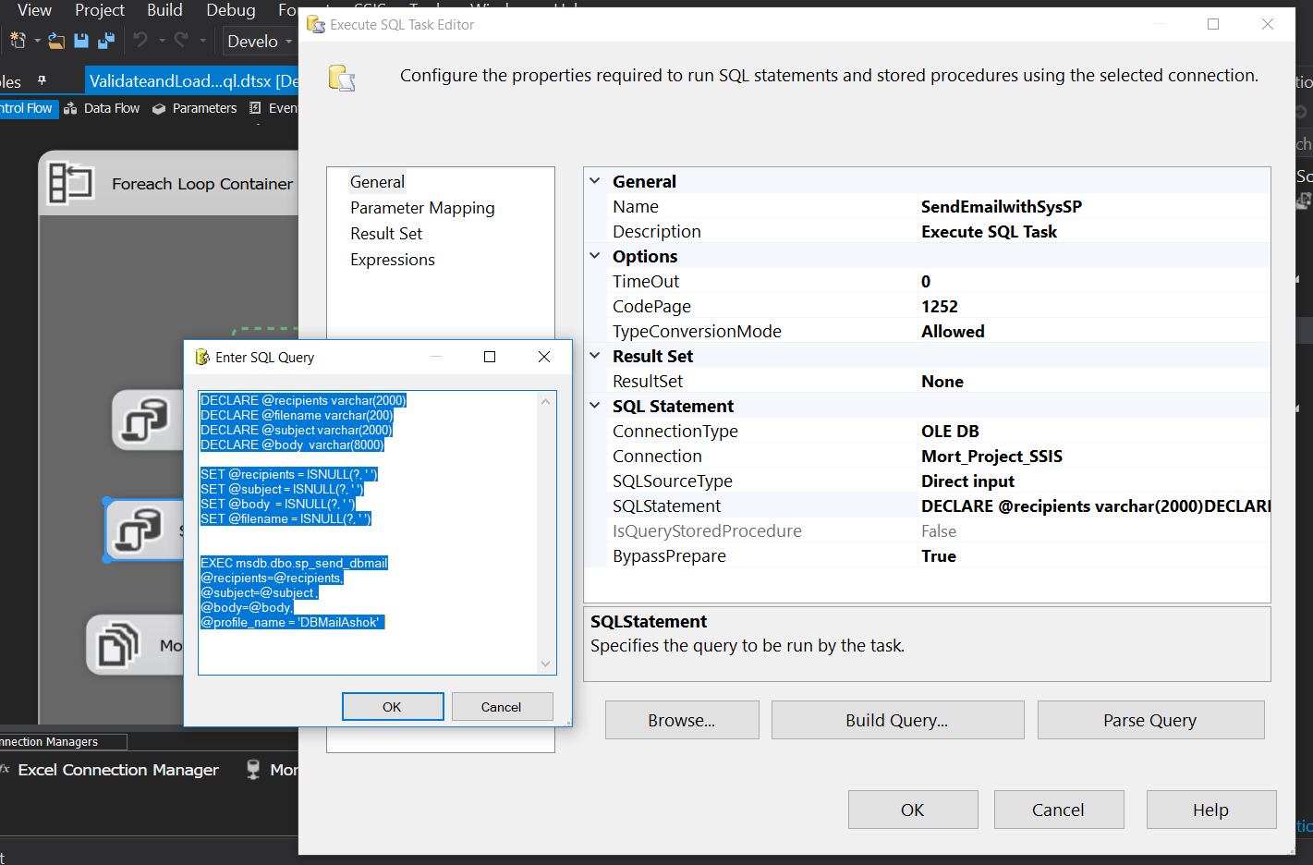

Here we use execute SQL task editor where we are going to use stored procedure to send email where we use created body subject end the recipients detail

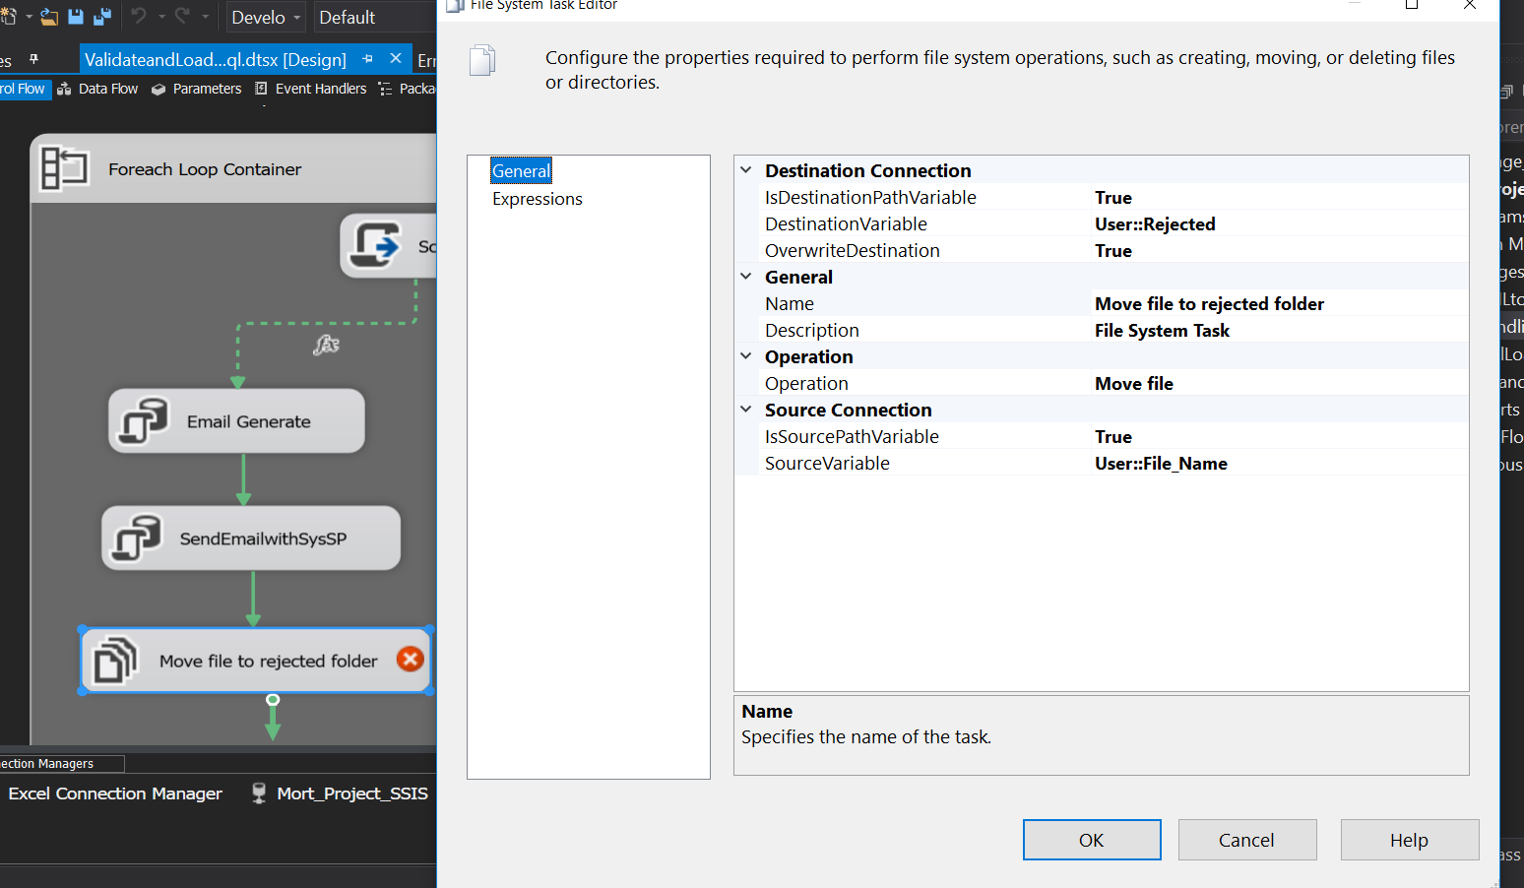

Above image shows that we use move file task to move the Excel file which had errors. This way we can validate the excel files.

Video(s) to Submit:

1. Copy and paste the link to your video(s) as part of your homework.

* SQL BI Interview Questions: SSIS – What is MULTICAST, MERGE JOIN and CONDITIONAL SPLIT

<https://app.colaberry.com/app/ipbc/videos?user=31221&category=37>

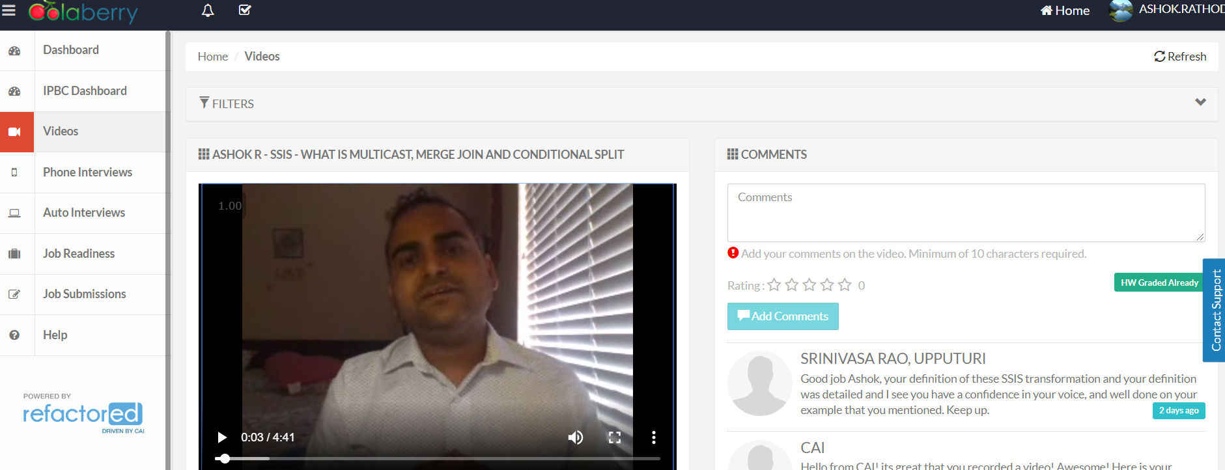

* SQL BI Interview Questions: SSIS – What is the difference between UNION ALL and MERGE Transformations <https://app.colaberry.com/app/ipbc/videos?user=31221&category=37>

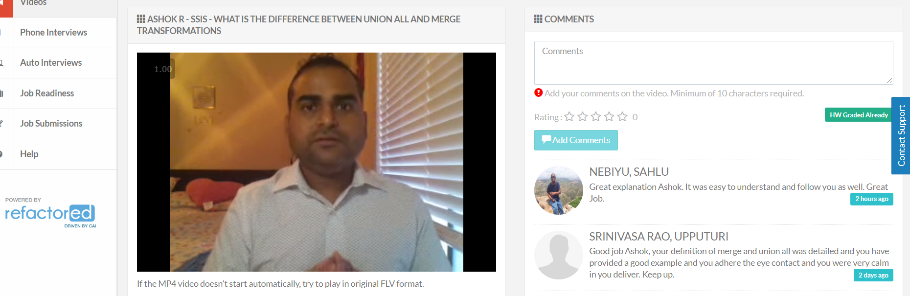

What to Submit:

1. Watch, Comment &amp; take screenshots of your comments from 3 other videos on the same topic (per question). Comments must be 20+ characters. Leave comments based on presentation, delivery and/or technical details. Your critiques will help you be more conscious of your own vide1os. (3 comment screenshots per Video Question)

* What is MULTICAST, MERGE JOIN and CONDITIONAL SPLIT

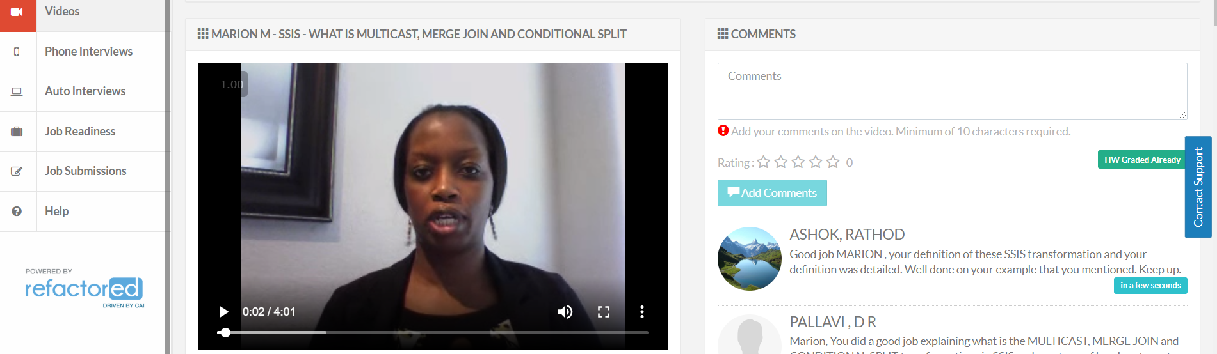 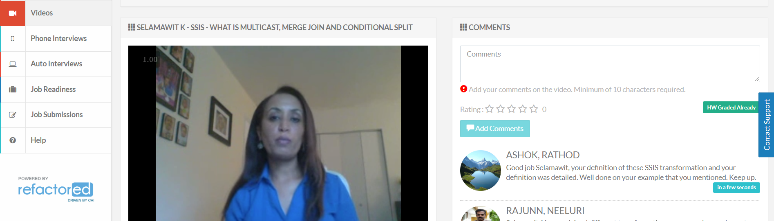

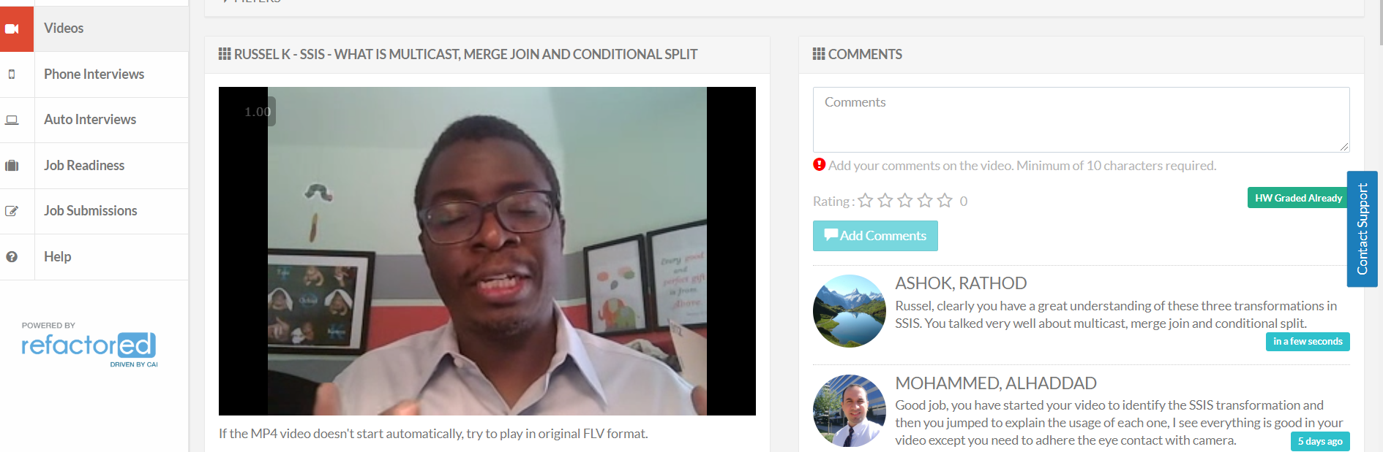

* What is the difference between UNION ALL and MERGE Transformations

